Sight word Chant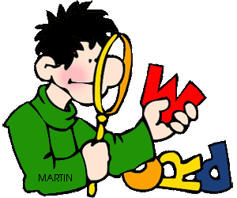

Here are 24 words you need,

if you want to write and read.

the we I to
and it up do
is at my see
go he a me
like on in an
so no am you

Know these words and you’ll read too!

